PySPARK in Windows using Jupyter Notebook
Many tutorials are available on the internet. That gives step by step guide for installing
- Spark
- Anaconda python package that contains jupyter notebook
- Setting up environment variables.
Some good tutorials are:
https://medium.com/@naomi.fridman/install-pyspark-to-run-on-jupyter-notebook-on-windows-4ec2009de21f
https://acadgild.com/blog/spark-integration-with-jupyter-notebook-in-10-minutes

Running PySpark:
After installing spark, Python and setting up environment variables you can run Pyspark shell by typing PySpark in cmd (command prompt) or Anaconda cmd or through jupyter notebook.
Run and follow the following steps in jupyter notebook
Step 1: Find spark in jupyter notebook and Import Spark libraries.
import findspark
findspark.init()

import pyspark
from pyspark.sql import *
from pyspark import SparkContext, SparkConf
Step 4: Create Spark session and Context.
# create the session
conf = SparkConf().setMaster("local").setAppName("My app")
# create the context
sc = pyspark.SparkContext(conf=conf)
spark = SparkSession.builder.getOrCreate()
Step 5: Run PySpark and view Spark Web interface.
spark
After executing this you can see the details. If you click on Spark UI it will take you to Spark web interface. In the Spark UI, you can monitor the progress of your job and debug the performance bottlenecks (if your Colab is running with a local runtime).
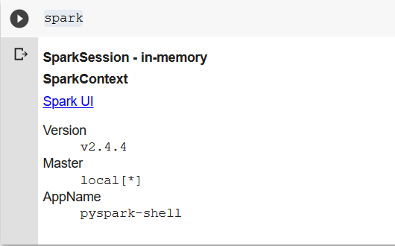
Click on Spark UI to open (in case you are using a proxy then first switch it off)
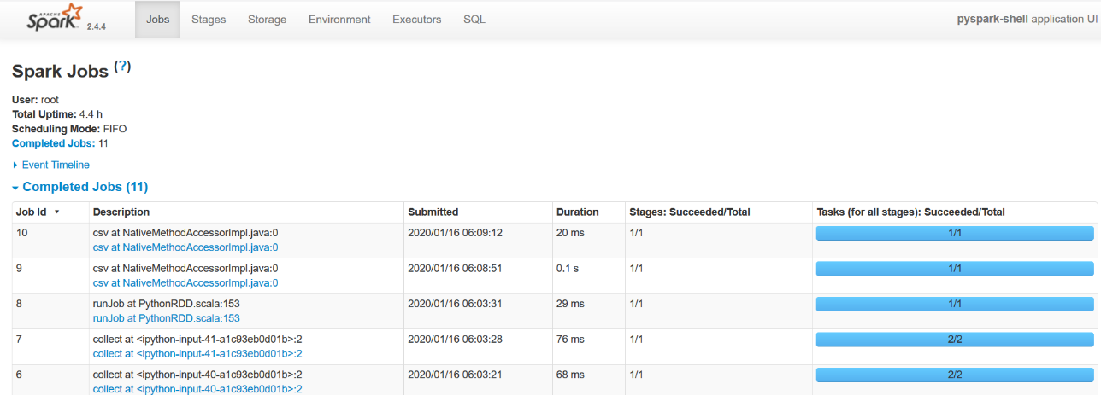

Now, you can upload data to the notebook and start writing your PySpark code.
nums = sc.parallelize([1,2,3,4])
nums.collect()

inputfile = sc.textFile("F:\input.txt")
inputfile.count()
inputfile.first()
infile = inputfile.filter(lambda x: "and" in x)
infile.count()
output1 = inputfile.map(lambda line: line.split(" ")).filter(lambda line: len(line)>5)
output1.count()
output1.collect()

